

Project Plan

“Media Bazaar”

Student| Student number:

I B | x

Tudor Rusu | x

E P| x

Viktor Kalinkov | x

FONTYS UNIVERSITY OF APPLIED SCIENCES

**HBO-ICT: English Stream**

February 2024

Table of Contents

INTRODUCTION 3

PROJECT STATEMENT 4

Formal Client 4

Current Situation 4

Project Goal 4

PROJECT OBJECTIVES 5

Project Approach 5

Project Deliverables and Non-Deliverables 5

Main features of the products 6

Project Constraints 6

Project Risks 6

PROJECT PHASING 8

# INTRODUCTION

Client hardware store chain “Media Bazaar” (daughter company of “Jupiter”) is hiring a team of software developers to implement the administrative system. The client communicates with the team via weekly meetings scheduled in advance by the team. The software team called “SystemTechies” consist of four members (Edita, Ivona, Tudor, Viktor). The administrative system should aid in managing employee data and help regulate stock levels. The team was tasked to analyze the current situation and provide a working software solution to address all the issues.

# PROJECT STATEMENT

# 

## Formal Client

The client is company “Media Bazaar” (daughter company of “Jupiter”) who is represented by Mr. Stan van Hartingsveldt.

**Contact Information:**

**Email client: x**



**Email tutor: x**

## Current Situation

Media Bazaar has no existing administrative software and is unable to properly manage their workforce as well as keep up with depleting products in shelves. Regarding managing the workforce, the client expressed interest in automated employee shift assignment, keeping track of their attendance as well as overview of employee information. Concerning stock levels, client would like to manage shelf restock requests.

The solution should be provided within upcoming six weeks. There are multiple developer teams working on the similar solutions at the same time.

## Project Goal

The goal of this project is to provide the client with a working software solution to help manage shelf stock, employees shifts and a statistical overview on employees and products within the given deadline.

# PROJECT OBJECTIVES

## Project Approach

The project is handled by a group of four members. The team is guided by a tutor Chung Kuah. In order to track the progress, two meetings with the tutor are scheduled each week. The project follows the Waterfall method, which is explained in more detail in Phasing section. The team distributed the workload using trello.com, to see all the small tasks and help each other when needed. In order to keep track of the evolution of application Git will be used for version control.

## Project Deliverables and Non-Deliverables

The final product will be represented by a working software solution that will help the client handle employee and stock management.

#### Deliverables for the Tutor

* Agendas and Minutes of each meeting
* Project Plan
* URS document
* Project Report
* Test Plan of the application
* Test Report of other groups’ systems

#### Deliverables for the Client

* Final Presentation
* Working Software solution
* Product and employee DB

#### Non-Deliverables (for the first 6 weeks)

* Website for employees to update their data
* Access to work rules & regulations
* Employee availability form
* Schedule visibility for the floor employees
* User manual is not included

## Main features of the products

* Login form to allow differentiate access per user group
* GUI tailored to clients’ preferences

|  |  |  |
| --- | --- | --- |
| Floor Employee | Administrative Employee | Managerial Employee |
| Live stock update | CRUD options for employee DB | Sales overview per product/department |
| CRUD option for product DB | Automated rotating shift assignment | Announcement tab (to floor employees) |
| Information panel (for msg from management) | Marking employee unavailability (sickness, holidays etc.) | Employee performance statistics overall and per department |
|  | Employee performance overview | Employee growth per department |

## Project Constraints

* The team is limited in time - six weeks for part I
* Workforce - 4 members only
* Programing language is C# using windows application
* Application language – English (US)
* Employee scheduling must comply to 0.1-1 FTE (full-time equivalent)
* All data privacy must be GDPR (General Data Protection Regulation) compliant

## Project Risks

Potential (external) dependencies that may impede work and how to avoid or minimize it:

|  |  |  |  |
| --- | --- | --- | --- |
| Risk | Impact | Occurrence | Prevention |
| Server dependency | High | Unlikely | Backing up all the data on a separate server |
| Losing team member | Medium | Unlikely | Sharing information on each other tasks to aid in workload overtaking if needed |
| Disputes among stakeholders | Medium | Unlikely | Proper communication, compromising |
| Data security risk | High | Likely | Planning work and meetings to be more private |

# PROJECT PHASING

The project has been split into 4 main parts (phases), that all end with different milestones (deliverables). In the chart below all steps are generalized for simplicity with the time the team expects to provide for each activity.

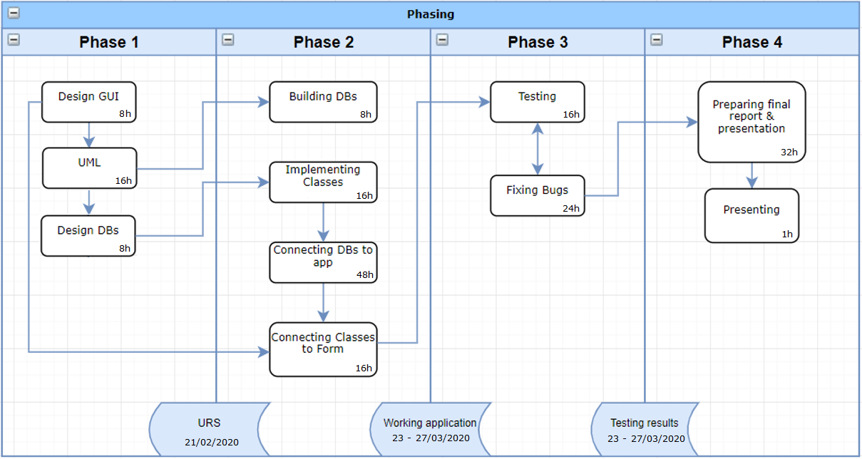

Figure 1. Workflow chart

A final presentation of the working solution to the customer and evaluation marks the end of the project part I.

Frank Henning